# **Descon**

# **Structural Super Combo**

## *Final Report Of The Project*

The aim of the project was to learn Basic of Designing (buildings, bridges, etc.) through general-purpose civil engineering software called SAP2000 which is mainly used for analyzing and designing structural systems.  
  
The duration of the project was of 6 weeks where we were given Some Tasks and assignments each week along with the necessary reference material.

At first, the mentors guided us with the installation of SAP2000.

## First Half

We started with the basics like the Definition of trusses and Beams and learned how to solve trusses, the introduction of shear forces, bending moments, manually adjusting steel and concrete properties, applying loads, etc.

Also taking into consideration that deformation should be minimized along with Cost.

Here are Some of the structures we designed →

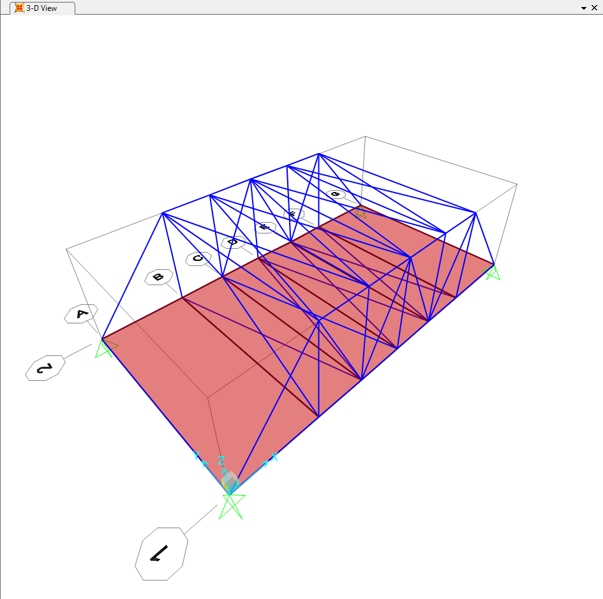

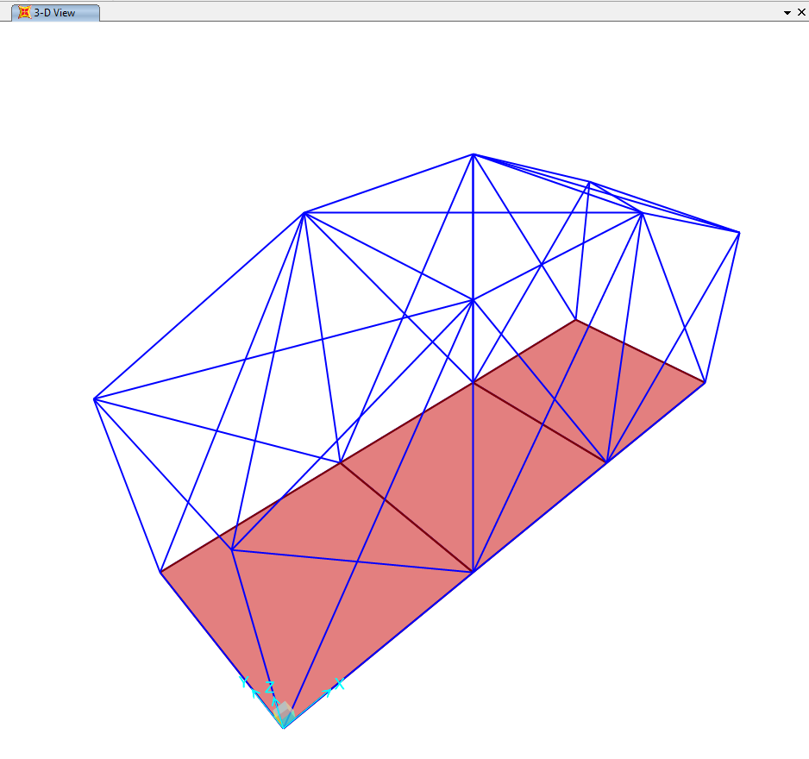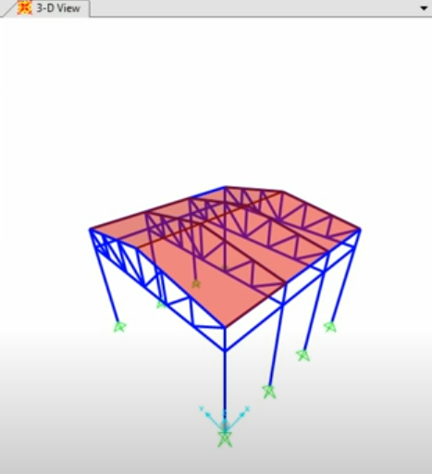

## Second Half

This part of the project covered beam and column theory. We started with the designing of the building with beams and columns, modeling shear walls, learned how to define diaphragms, meshing the slab, applying different types of loads like dead load, live load, Earthquake loads, calculating the time period for the building.

Also to verify if all the frame members pass the stress check and lastly ensuring that Beam/column capacity ratio does not exceed 1.

The building designed by me is shown below →

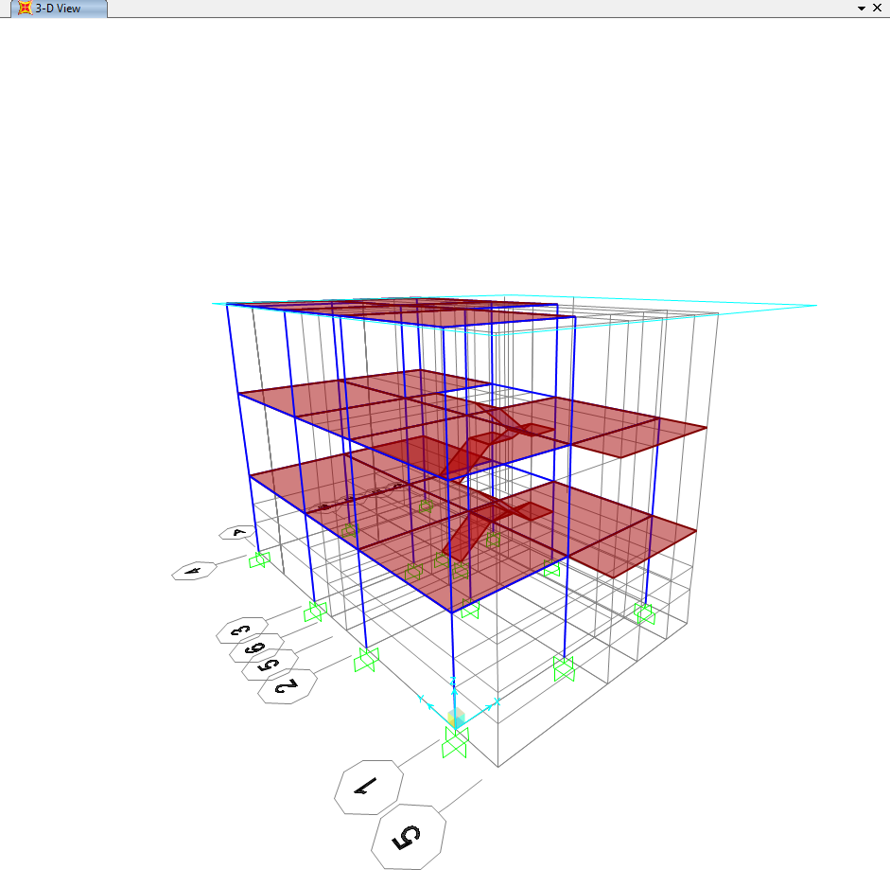

**Name** → **Yuvraj**  **(201170)**

**Mentors** → Aarjav Jain, Bidhan Arya, Mukesh Kumar, Kuldeep Meena